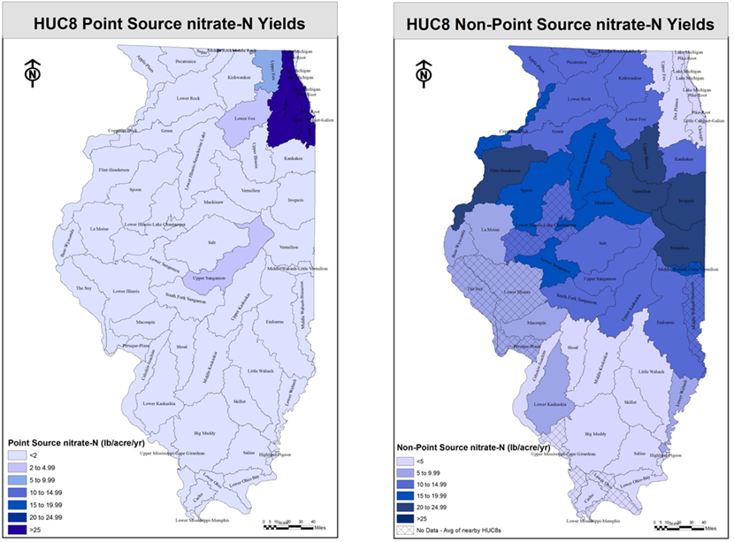
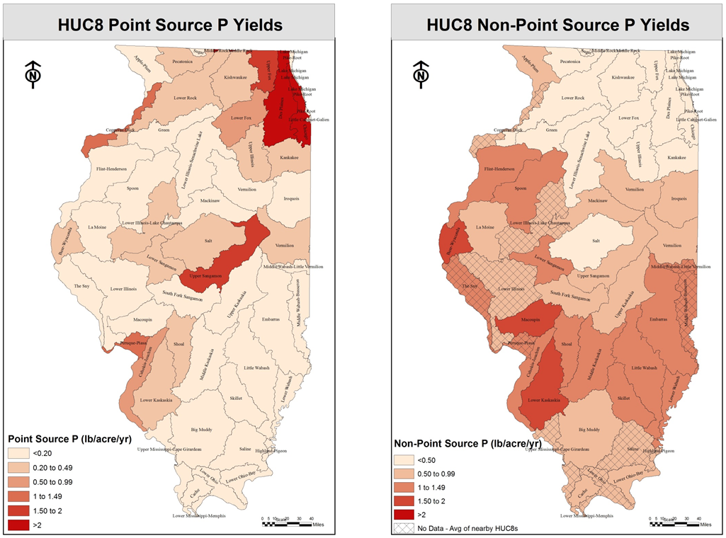
Table 3.11. Example statewide results for nitrate-nitrogen reductions with shading to represent in-field, edge-of-field, land use, and point source practices or scenarios.
Practice/scenario | Nitrate-N reduction per acre (percent) | Nitrate-N reduced (million lb) | Nitrate-N reduction from baseline (percent) | Cost ($/lb removed)
Reducing N rate from background to MRTN on 10 percent of acres | 10 | 2.3 | 0.6 | -4.25
Nitrification inhibitor with all fall-applied fertilizer on tile-drained corn acres | 10 | 4.3 | 1 | 2.33
Split application of 50 percent fall and 50 percent spring on tile-drained corn acres | 7.5-10 | 13 | 3.1 | 6.22
Spring-only application on tile-drained corn acres | 15-20 | 26 | 6.4 | 3.17
Split application of 40 percent fall, 10 percent pre-plant, and 50 percent side dress | 15-20 | 26 | 6.4
Cover crops on all corn/soybean tile-drained acres | 30 | 84 | 20.5 | 3.21
Cover crops on all corn/soybean non-tiled acres | 30 | 33 | 7.9 | 11.02
Bioreactors on 50 percent of tile-drained land | 25 | 35 | 8.5 | 2.21
Wetlands on 35 percent of tile-drained land | 50 | 49 | 11.9 | 4.05
Buffers on all applicable crop land (reduction only for water that interacts with active area) | 90 | 36 | 8.7 | 1.63
Perennial/energy crops equal to pasture/hay acreage from 1987 | 90 | 10 | 2.6 | 9.34
Perennial/energy crops on 10 percent of tile-drained land | 90 | 25 | 6.1 | 3.18
Point source reduction to 10 mg/L |  | 14 | 3.4 | 3.3

Table 3.14. Example statewide results for total phosphorus reductions by practice/scenario with shading to represent in-field, edge-of-field, land use changes, and point source practices or scenarios.
Practice/scenario | Total P reduction per acre (percent) | Total P reduced (million lb) | Total P reduction from baseline (percent) | Cost ($/lb removed)
1.8 million acres of conventional till eroding >T converted to reduced, mulch, or no-till | 50 | 1.8 | 5 | -16.6
P rate reduction on fields with soil test P above the recommended maintenance level | 7 | 1.9 | 5 | -48.75
Cover crops on all corn/soybean tile-drained acres | 30 | 4.8 | 12.8 | 130.4
Cover crops on 1.6 million acres eroding >T currently in reduced, mulch, or no-till | 50 | 1.9 | 5 | 24.5
Wetlands on 25 percent of tile-drained land | 0 | 0 | 0
Buffers on all applicable crop land | 25-50 | 4.8 | 12.9 | 11.97
Perennial/energy crops equal to pasture/hay acreage in 1987 | 90 | 0.9 | 2.5 | 102.3
Perennial/energy crops on 1.6 million acres >T currently in reduced, mulch, or no-till | 90 | 3.5 | 9 | 40.4
Perennial/energy crops on 10 percent of tile-drained land | 50 | 0.3 | 0.8 | 250.07
Point source reduction to 1 mg/L (majors only) |  | 8.3 | 22.1 | 13.71

Table 3.15. Example statewide nitrate-nitrogen scenarios.
Name | Combined practices and scenarios | Nitrate-N (percent reduction) | Total P (percent reduction) | Cost of reduction ($/lb) | Annualized costs (million $/yr)
N1 | MRTN rate, spring-only N application, cover crops on 70 percent of tile-drained and 45 percent non-tiled acres, bioreactors on 50 percent of acres, wetlands on 30percent of acres, all ag streams have buffers | 45 | 20 | 3.96 | 728
N2 | MRTN rate, spring-only N application, cover crops on 100 percent of tile-drained and 70 percent of non-tiled acres, bioreactors on 75percent of acres, perennial crops on non-tiled acres, point source to 10 mg/L | 45 | 33 | 4.67 | 858
N3 | MRTN rate, cover crops on 100 percent of tile-drained and 70 percent of non-tiled acres, wetlands on 20 percent of acres, perennial crops on non-tiled acres, all ag streams have buffers, point source to 10 mg/L | 45 | 24 | 4.48 | 830
N4 | MRTN rate, spring-only N application, cover crops on 5 percent of tile-drained acres, bioreactors on 50 percent of acres, wetlands on 15 percent of acres | 20 | 0.3 | 3.00 | 246
N5 | MRTN rate, cover crops on 35 percent of tile-drained acres, bioreactors on 50 percent of acres, wetlands on 15 percent of acres | 20 | 2 | 3.00 | 246
N6 | MRTN rate, cover crops on 75 percent of tile-drained and 55 percent of non-tiled acres | 20 | 8 | 4.78 | 394

Table 3.16. Example statewide total phosphorus scenarios.
Name | Combined practices or scenarios | Nitrate-N (percent reduction) | Total P (percent reduction) | Cost of reduction ($/lb) | Annualized costs (million $/yr)
P1 | No P fertilizer on 12.5 million acres above STP maintenance, reduced till on 1.8 million conventionally tilled acres eroding >T, buffers on all applicable lands, point source to 1 mg/L | 7 | 45 | 2.84 | 48
P2 | No P fertilizer on 12.5 million acres above STP maintenance, reduced till on 1.8 million conventionally tilled acres eroding >T, cover crops on all corn/soybean acres, point source to 1 mg/L | 29 | 45 | 36.44 | 615
P3 | No P fertilizer on 12.5 million acres above STP maintenance, reduced till on 1.8 million conventionally tilled acres eroding >T, cover crops on 87.5 percent of corn/soybean acres, buffers on all applicable lands, perennial crops on 1.6 million acres >T and 0.9 million additional acres | 38 | 45 | 41.24 | 696
P4 | No P fertilizer on 12.5 million acres above STP maintenance, reduced till on 1.8 million conventionally tilled acres eroding >T, buffers on 80 percent of all applicable land | 6 | 20 | -10.40 | -78
P5 | No P fertilizer on 12.5 million acres above STP maintenance, reduced till on 1.8 million conventionally tilled acres eroding >T, point source to 1 mg/L on 45 percent of discharge | 0 | 20 | -9.73 | -73
P6 | No P fertilizer on 12.5 million acres above STP maintenance, reduced till on 1.8 million conventionally tilled acres eroding >T, cover crops on 1.6 million acres eroding >T and 40 percent of all other corn/soybean acres | 11 | 20 | 22.93 | 172

Table 3.17. Example statewide nitrate-nitrogen and total phosphorus scenarios.
Name | Combined practices and scenarios | Nitrate-N reduction (percent) | Total P reduction (percent) | Cost of reduction ($/lb) | Annualized costs (million $/yr)
NP1 | MRTN, spring-only N application, bioreactors on 50 percent of acres, wetlands on 35 percent of acres, no P fertilizer on 12.5 million acres above STP maintenance, reduced till on 1.8 million conventionally tilled acres eroding >T, buffers on all applicable lands, point source to 1 mg total P/L and 10 mg nitrate-N/L | 35 | 45 | ** | 438
NP2 | MRTN, spring-only N application, bioreactors on 50 percent of acres, wetlands on 10 percent of acres, no P fertilizer on 12.5 million acres above STP maintenance, reduced till on 1.8 million conventionally tilled acres eroding >T, cover crops on all corn/soybean acres, point source to 1 mg total P/L and 10 mg nitrate-N/L | 45 | 45 | ** | 878
NP3 | MRTN, spring-only N application, bioreactors on 30 percent of acres, no P fertilizer on 12.5 million acres above STP maintenance, reduced till on 1.8 million conventionally tilled acres eroding >T, cover crops on 87.5 percent of corn/soybean acres, buffers on all applicable lands, perennial crops on 1.6 million acres >T and 0.9 million additional acres | 45 | 45 | ** | 827
NP4 | MRTN, spring-only N application, bioreactors on 53 percent of acres, no P fertilizer on 12.5 million acres above STP maintenance, reduced till on 1.8 million conventionally tilled acres eroding >T, buffers on 80 percent of all applicable land | 20 | 20 | ** | 76
NP5 | MRTN, spring-only N application, bioreactors on 45 percent of acres, wetlands on 15 percent of acres, no P fertilizer on 12.5 million acres above STP maintenance, reduced till on 1.8 million conventionally tilled acres eroding >T, point source to 1 mg total P/L and 10 mg nitrate-N/L on 45 percent of discharge | 20 | 20 | ** | 173
NP6 | MRTN, spring-only N application, no P fertilizer on 12.5 million acres above STP maintenance, reduced till on 1.8 million conventionally tilled acres eroding >T, cover crops on 1.6 million acres eroding >T and 40 percent of all other corn/soybean acres | 24 | 20 | ** | 244

